**Problems**

**on Double integrals over general regions**

*Due date*: **15 Ashwin, 2081**

**Evaluate the iterated integral.**

**1. $\int_{0}^{1}{\int_{x^{2}}^{x}{xy^{2} dy dx}}$**

**Ans**. 1/40

**2. $\int_{1}^{3/2}{\int_{y}^{3-y}{y dx dy}}$**

**Ans**. 7/24

**3. $\int_{0}^{3}{\int_{0}^{\sqrt{9-y^{2}}}{y dx dy}}$**

**Ans**. 9

**4. $\int_{1/4}^{1}{\int_{x^{2}}^{x}{\sqrt{\frac{x}{y}} dy dx}}$**

**Ans**. 13/80

**5. $\int_{\sqrt{}}^{\sqrt{2}}{\int_{0}^{x^{3}}{\sin{\frac{x}{y}} dy dx}}$**

**Ans**. π/2

**6. $\int_{-1}^{1}{\int_{-x^{2}}^{x^{2}}{(x^{2}-y) dy dx}}$**

**Ans**. 4/5

**7. $\int_{0}^{1}{\int_{0}^{x}{y\sqrt{x^{2}-y^{2}} dy dx}}$**

**Ans**. 1/12

**8. $\int_{1}^{2}{\int_{0}^{y^{2}}{e^{x/y^{2}} dx dy}}$**

**Ans**. 7(*e* – 1)/3

**Use an iterated integral to find the area of the shaded region.**

**9.**

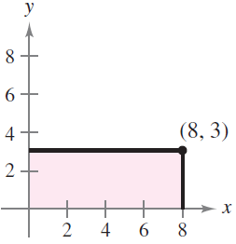

**Ans**. 24

**10.**

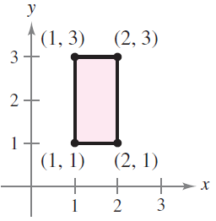

**Ans**. 2

**11.**

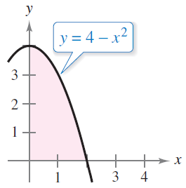

**Ans**. 16/3

**Use double integration to find the area of the plane region**

**enclosed by the given curves.** ■

**12.** *y* = sin *x* and *y* = cos *x*, for 0 ≤ *x* ≤ *π/*4.

**Ans**. – 1

**13.** *y*2 = −*x* and 3*y* − *x* = 4.

**Ans.** 125/6

**14.** *y*2 = 9 − *x* and *y*2 = 9 − 9*x*.

**Ans.** 32

**Use a double integral to find the volume of the indicated solid.**

**15.**

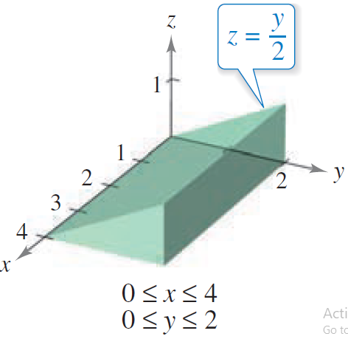

**Ans**. 4

**16.**

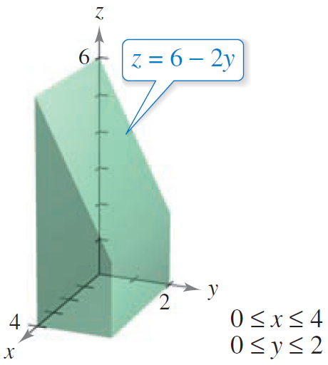

**Ans**. 32

**17.**

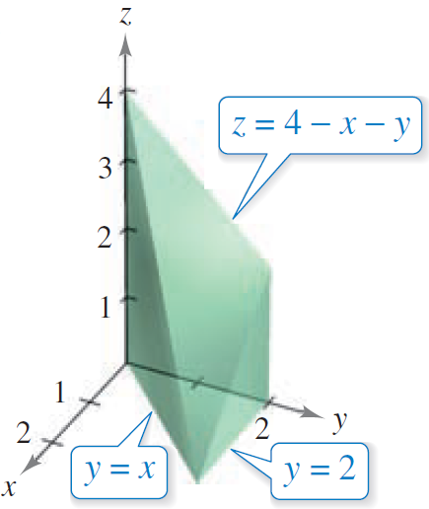

**Ans**. 4

**18.**

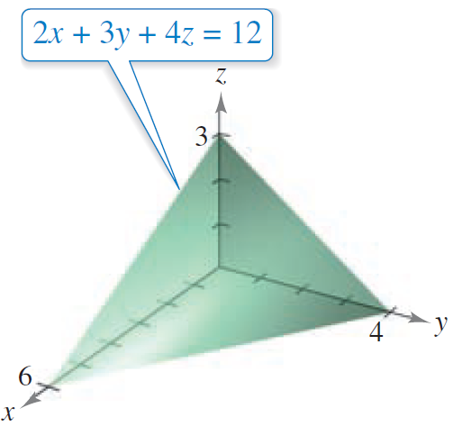

**Ans**. 12

**19.**

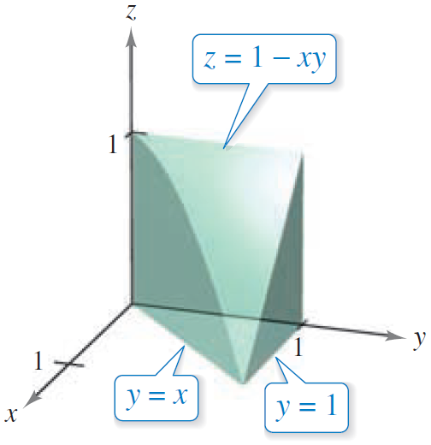

**Ans**. 3/8

**20.**

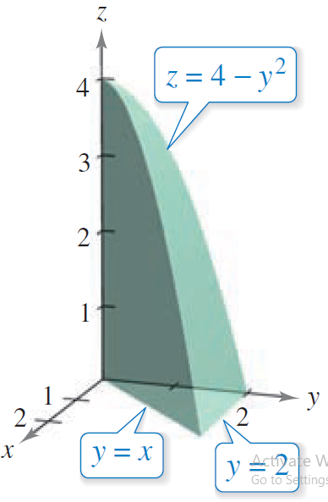

**Ans**. 4

**Use double integration to find the volume of each solid.**

**21.** The solid bounded by the cylinder *x*2 + *y*2 = 9 and the planes *z* = 0 and *z* = 3 − *x*.

**Ans.** 27π

**22.** The solid in the first octant bounded above by the paraboloid *z* = *x*2 + 3*y*2, below by the plane *z* = 0, and laterally by *y* = *x*2 and *y* = *x*.

**Ans.** 11/70

**23.** The solid bounded above by the paraboloid *z* = 9*x*2 + *y*2, below by the plane *z* = 0, and laterally by the planes *x* = 0, *y* = 0, *x* = 3, and *y* = 2.

**Ans.** 170

**24.** The solid enclosed by *y*2 = *x*, *z* = 0, and *x* + *z* = 1.

**Ans.** 8/15

**25.** The wedge cut from the cylinder 4*x*2 + *y*2 = 9 by the planes *z* = 0 and *z* = *y* + 3.

**Ans.** 27π/2

**26.** The solid in the first octant bounded above by *z* = 9 − *x*2, below by *z* = 0, and laterally by

*y*2 = 3*x*.

**Ans.** 216/7

**Sketch the region of integration and change the order of**

**integration.**

**27. $\int_{0}^{2}{\int_{0}^{\sqrt{x}}{f(x, y) dy dx}}$**

**28. $\int_{0}^{4}{\int_{1}^{8}{f(x, y) dx dy}}$**

**29. $\int_{0}^{2}{\int_{1}^{e^{y}}{f(x, y) dx dy}}$**

**30. $\int_{1}^{e}{\int_{0}^{\ln{x}}{f(x, y) dy dx}}$**

**31. $\int_{0}^{1}{\int_{\sin^{-1}{y} }^{/2}{f(x, y) dx dy}}$**

**32. $\int_{0}^{1}{\int_{y^{2}}^{\sqrt{y}}{f(x, y) dx dy}}$**

**Set up integrals for both orders of integration. Use the more convenient order to evaluate the integral over the region *R***

**33.** ∫∫ *dA*

*R*: trapezoid bounded by *y* = *x*, *y* = 2*x*, *x* = 1, *x* = 2

**Ans**. ln(5/2)

**34.** ∫∫*xey dA*

*R*: triangle bounded by *y* = 4 – *x*, *y* = 0, *x* = 0

**Ans**. *e*4 – 13

**35.** ∫∫(–2*y*) *dA*

*R*: trapezoid bounded by *y* = 4 – *x*2, *y* = , *x* = 4

**Ans**. 6/5

**36.** ∫∫ *dA*

*R*: region bounded by *y* = 0, *y* = 4 – *x*

**Ans**. ln(17)

**37.** ∫∫*x* *dA*

*R*: sector of a circle in the first quadrant bounded by *y* = , *y* = 0, 3*x* – 4*y* = 0

**Ans**. 25

**38.** ∫∫ (*x*2 + *y*2) *dA*

*R*: semicircle bounded by *y* = , *y* = 0

**Ans**. 4π

**Evaluate the integral by first reversing the order of integration.**

**39. $\int_{0}^{1}{\int_{4x}^{4}{e^{{-y}^{2}} dy dx}}$**

**Ans. $\frac{1-e^{-16}}{8}$**

**40. $\int_{0}^{2}{\int_{y/\sqrt{2 }}^{3}{\cos{x^{2}} dx dy}}$**

**Ans.** sin 1.

**41. $\int_{0}^{4}{\int_{\sqrt{y}}^{2}{e^{x^{3}} dx dy}}$**

**Ans. $\frac{e^{8}-1}{3}$**

**42. $\int_{1}^{3}{\int_{0}^{\ln{x}}{x dy dx}}$**

**Ans. $\frac{9\ln{3}-4}{2}$**

**43. $\int_{0}^{4}{\int_{\sqrt{x}}^{2}{ \frac{3}{2+y^{3}} dy dx}}$**

**Ans.** ln 5

**44. $\int_{0}^{2}{\int_{y^{2}}^{4}{\sqrt{x} sin{x} dx dy}}$**

**Ans.** sin 4 – 4 cos 4

≈ 1.858.

**45.** Find the average value of 1*/(*1 + *x*2*)* over the triangular region with vertices (0*,* 0), (1*,* 1), and (0*,* 1).

**Ans. (**π/2) – ln 2

**46.** Find the average value of *f(x, y)* = *x*2 − *xy* over the region enclosed by *y* = *x* and *y* = 3*x* − *x*2.

**Ans.** –2/5

**47.** Suppose that the temperature in degrees Celsius at a point *(x, y)* on a flat metal plate is

*T* (*x, y*)= 5*xy* + *x*2, where *x* and *y* are in meters. Find the average temperature of the diamond-shaped portion of the plate for which |2*x* + *y*| ≤ 4 and |2*x* − *y*| ≤ 4.

**Ans.** (2/3)°C

**48.** A circular lens of radius 2 inches has thickness 1 − *(r*2*/*4*)* inches at all points *r* inches from the center of the lens. Find the average thickness of the lens.

**Ans**. 0.5 in